|  |  |
| --- | --- |
| Name: | Bodhisatya Ghosh |
| UID: | 2021700026 |
| Class: | CSE DS |
| Batch: | B |
| Experiment: | 4 |

**Aim :**  The aim of this experiment is to implement computationally Fast Algorithms.

**Objective :**

1. Develop a program to perform FFT of N point Signal.
2. Calculate FFT of a given DT signal and verify the results using mathematical formula.
3. Computational efficiency of FFT.

**Theory:**

* Definition: Fast Fourier Transform (FFT) is an efficient algorithm to compute the Discrete Fourier Transform (DFT) and its inverse. It transforms a sequence of N complex numbers into another sequence of complex numbers, revealing the frequency components of the input signal. FFT reduces the computation time significantly compared to the standard DFT calculation.
* Properties: Speed, Accuracy, Divide and Conquer, Symmetry, Recursive.
* Applications: Signal Processing, Spectral Analysis, Image Processing, Communication System, Scientific Computing, Data Compression, Acoustics, Financial Analysis

**Problem definition**:

* Take any four-point sequence x[n]. Find FFT of x[n] and IFFT of {X[k]}
* Calculate Real and Complex Additions & Multiplications involved to find X[k].

**Input specifications:**

1. Length of first Signal N
2. DT Signal values

**Code:**

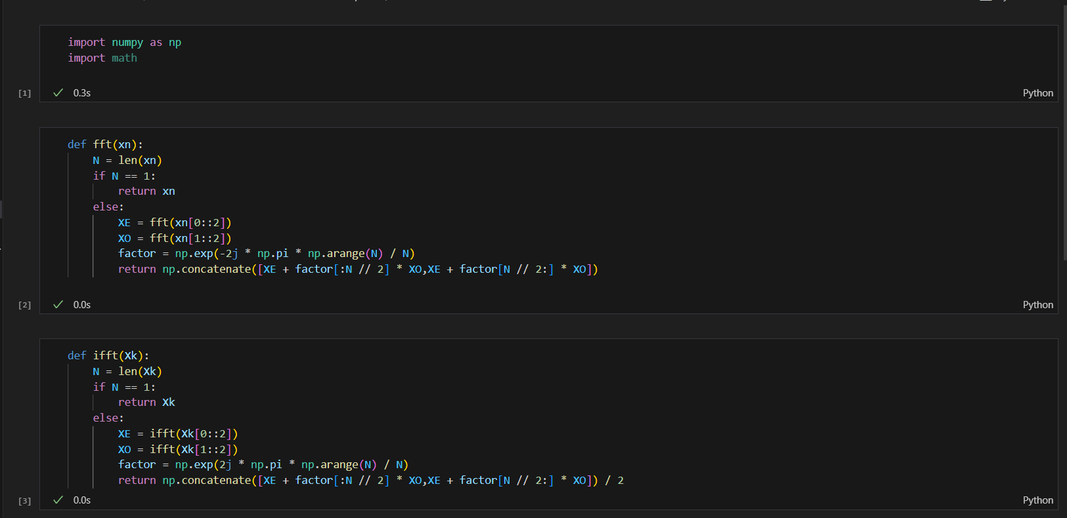

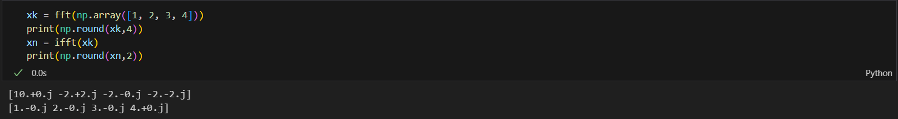

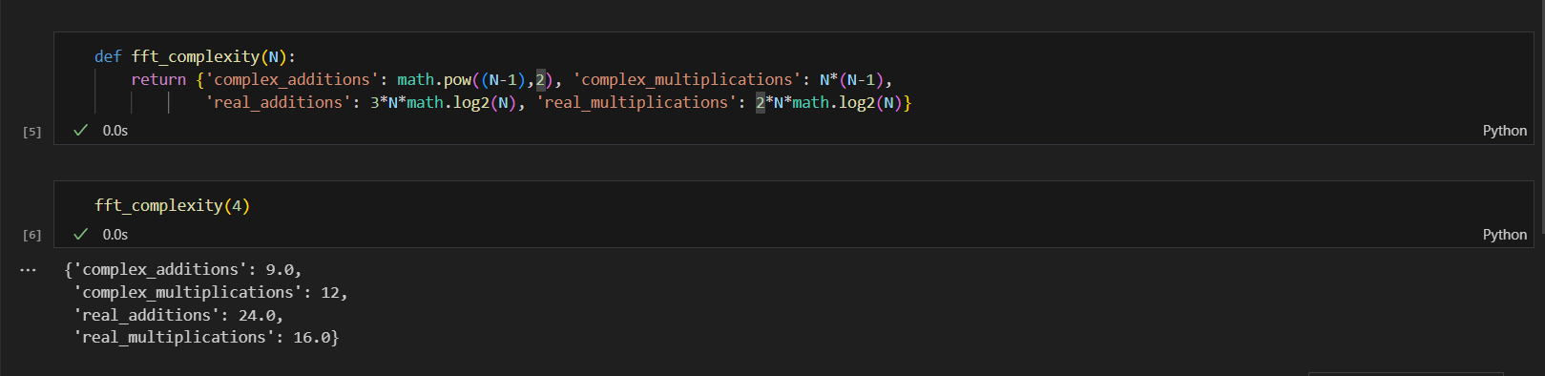

**Conclusion:**

1. The magnitude spectrum of the original 4-point sequence x[n] is plotted.
2. Appending 4 zeros to the input signal leads to a wider DFT spectrum with additional zero frequency components.
3. Expanding the input signal by inserting alternate zeros results in a wider DFT spectrum, with some zero frequency components.

---------------------------------------------------------------------------------------------------------

**Application**: Authentication using Audio Password Verification

using Energy Spectral Density

**Code:**

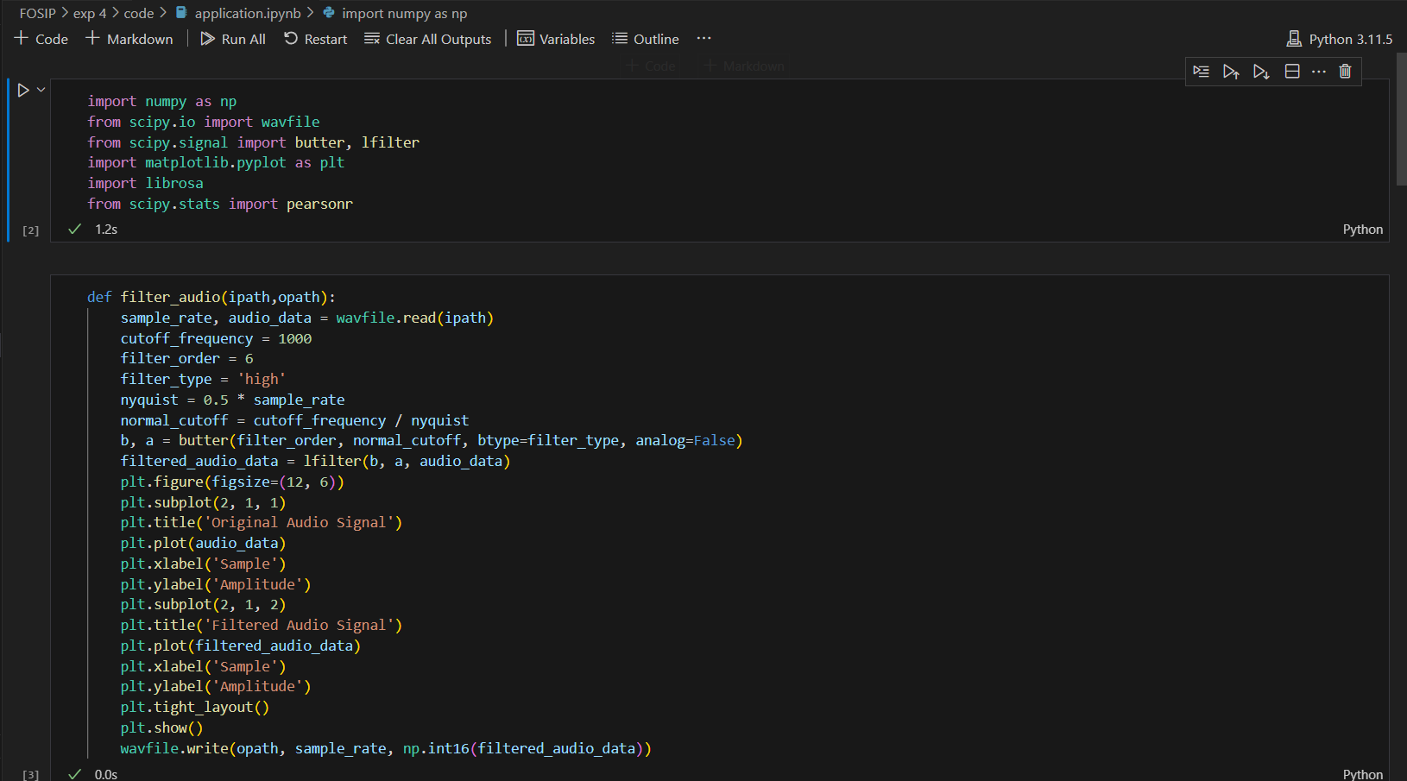

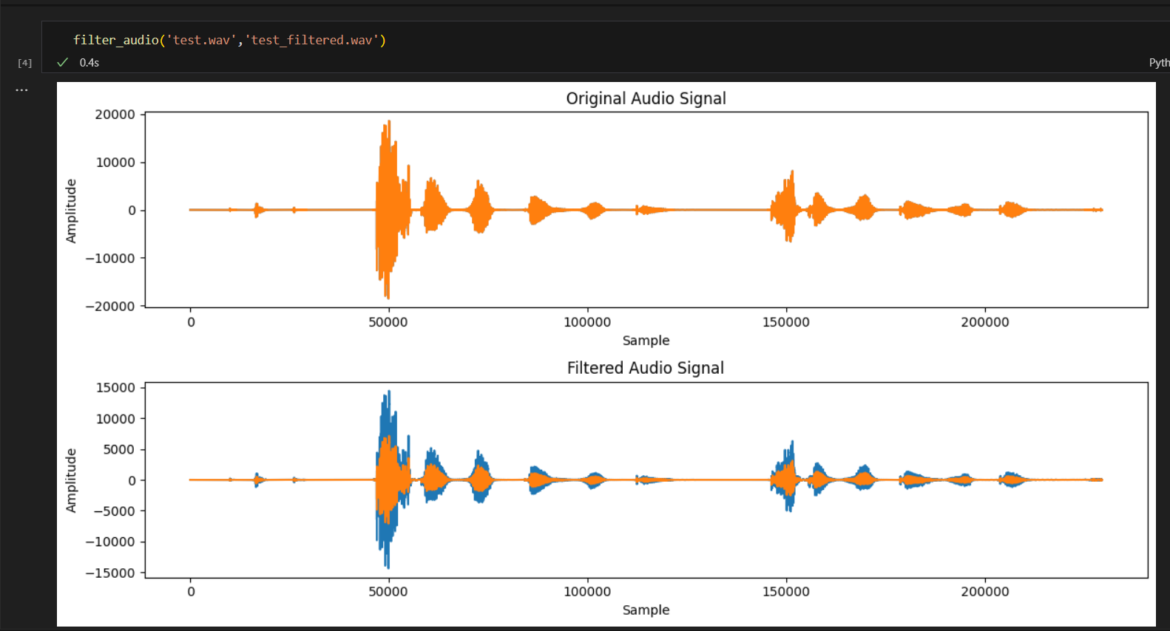

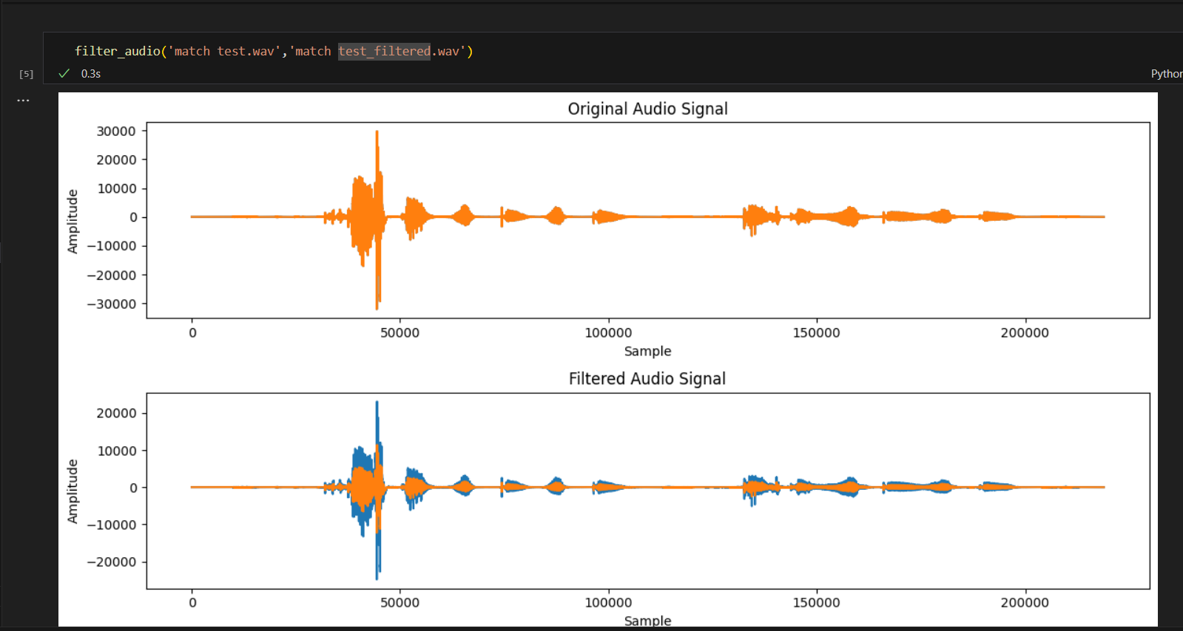

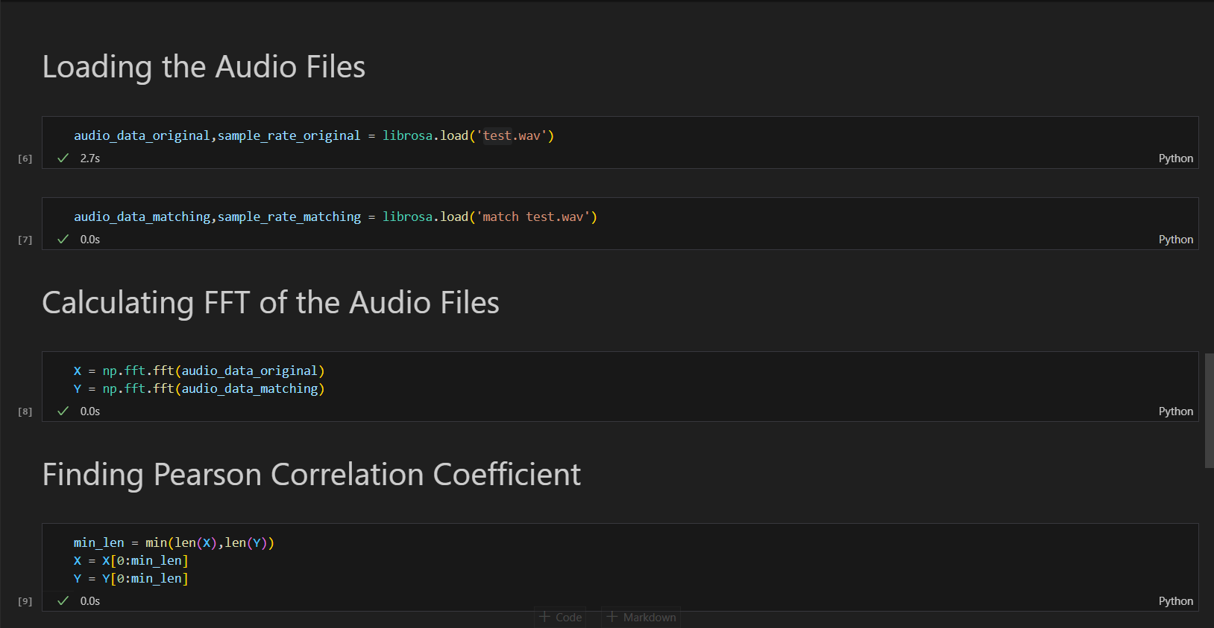

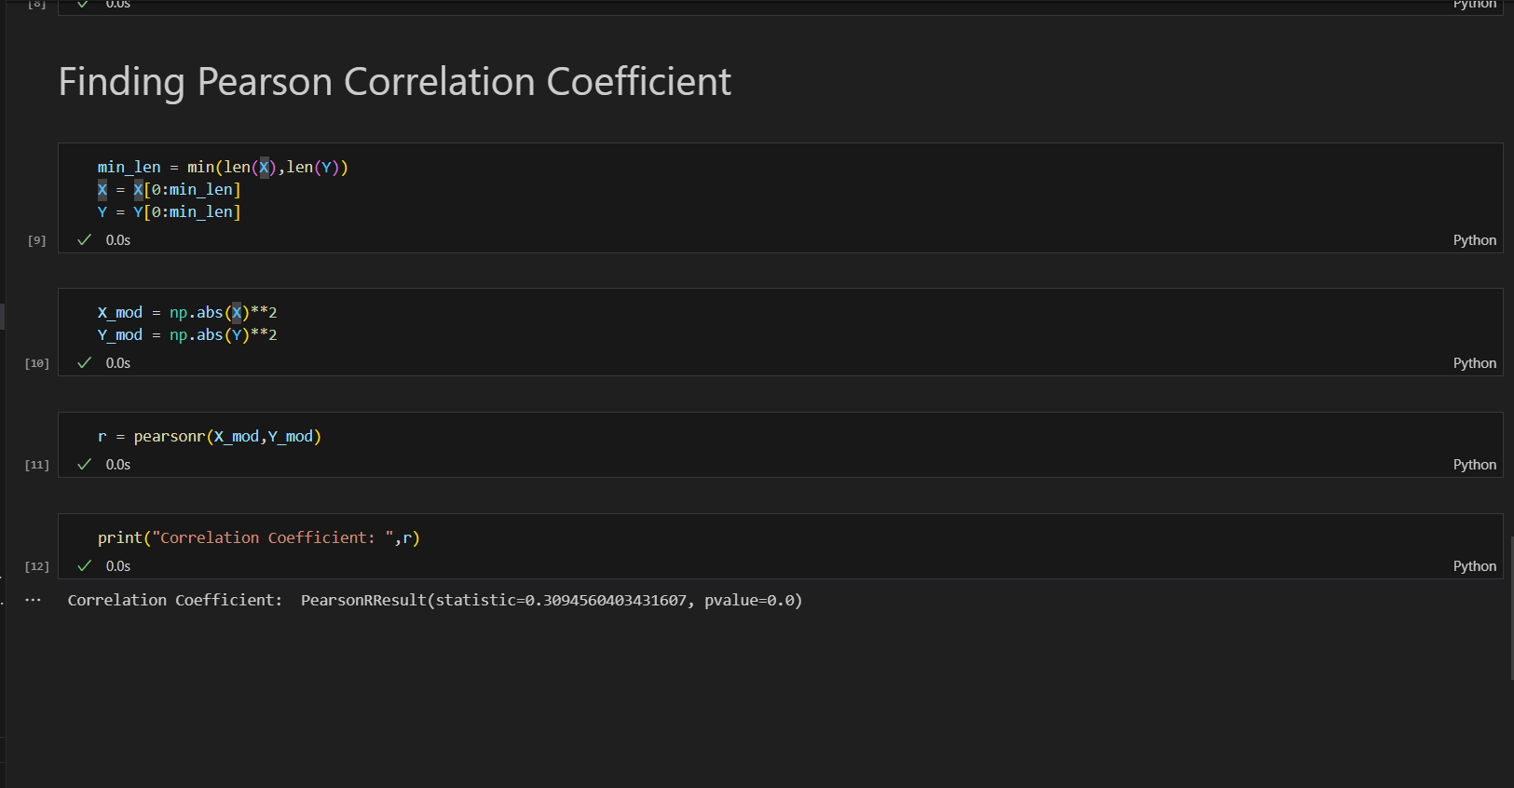

**CONCLUSION:**

In this experiment I learnt about FFT and IFFT and its real world applications. The experiment showcased the power of FFT in computational efficiency and real-world applications such as audio authentication.